Лабораторная работа №1. Логические элементы и логические функции.

Логические схемы
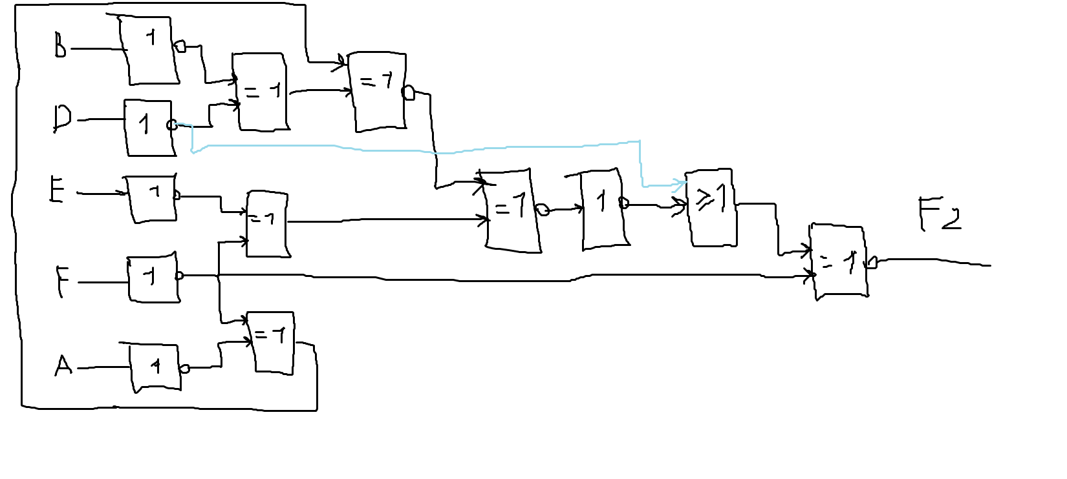
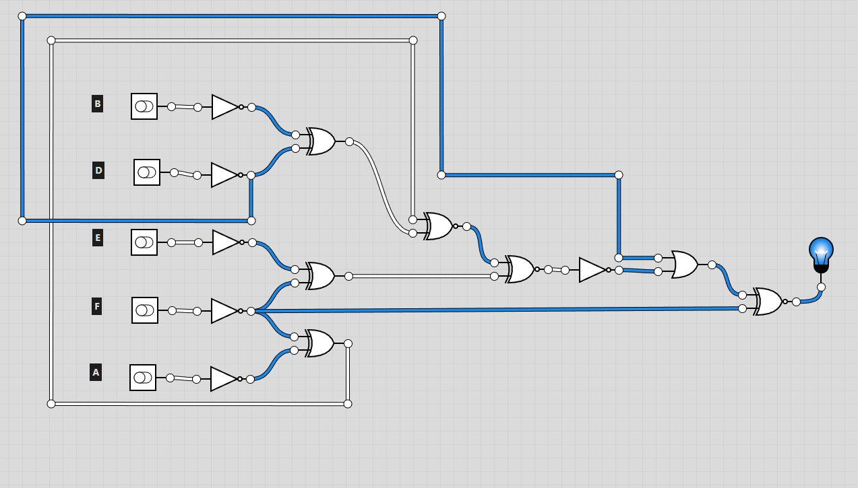

A | B | D | E | F | F2
0 | 0 | 0 | 0 | 0 | 1
0 | 0 | 0 | 0 | 1 | 0
0 | 0 | 0 | 1 | 0 | 1
0 | 0 | 0 | 1 | 1 | 0
0 | 0 | 1 | 0 | 0 | 0
0 | 0 | 1 | 0 | 1 | 1
0 | 0 | 1 | 1 | 0 | 1
0 | 0 | 1 | 1 | 1 | 0
0 | 1 | 0 | 0 | 0 | 1
0 | 1 | 0 | 0 | 1 | 0
0 | 1 | 0 | 1 | 0 | 1
0 | 1 | 0 | 1 | 1 | 1
0 | 1 | 1 | 0 | 0 | 1
0 | 1 | 1 | 0 | 1 | 0
0 | 1 | 1 | 1 | 0 | 0
0 | 1 | 1 | 1 | 1 | 1
1 | 0 | 0 | 0 | 0 | 1
1 | 0 | 0 | 0 | 1 | 0
1 | 0 | 0 | 1 | 0 | 1
1 | 0 | 0 | 1 | 1 | 0
1 | 0 | 1 | 0 | 0 | 1
1 | 0 | 1 | 0 | 1 | 0
1 | 0 | 1 | 1 | 0 | 0
1 | 0 | 1 | 1 | 1 | 1
1 | 1 | 0 | 0 | 0 | 1
1 | 1 | 0 | 0 | 1 | 0
1 | 1 | 0 | 1 | 0 | 1
1 | 1 | 0 | 1 | 1 | 0
1 | 1 | 1 | 0 | 0 | 0
1 | 1 | 1 | 0 | 1 | 1
1 | 1 | 1 | 1 | 0 | 1
1 | 1 | 1 | 1 | 1 | 0

вывод

